Description of Equine
Name/Registered Name |  | Registration Number  (Example: Unique Equine Life Number, Breed Registry Number, etc. Required, if issued. If none, enter NONE)
Species and Breed |  | Microchip and Location  (Required, if present. If none, enter NONE)
Colour |  | Tattoo or Brand  (Required, if present. If none, enter NONE)
Sex |  | Age
Silhouette or Photographs
(Show all permanent white markings, brands, tattoos, scars, whorls, and microchip location.)
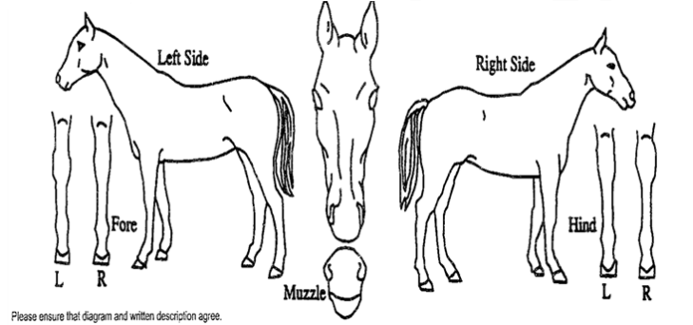
Head |  | Neck and Body
Left Forelimb |  | Right Forelimb
Left Hindlimb |  | Right Hindlimb
Authorised veterinarian*
Name: |  |  | Phone number: | __________________________
Practice address:
Signature: |  |  | Date:
* An authorised veterinarian is a licensed veterinarian approved or accredited by the Competent Authority to perform certain official tasks associated with animal health on their behalf, such as inspection and certification of commodities for international movement.

